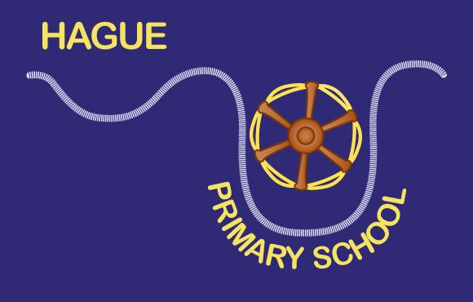
HAGUE PRIMARY SCHOOL
Wilmot Street, Bethnal Green
London, E2 0BP

Tel: 0207 739 9574
E-mail: admin@hague.towerhamlets.sch.uk
Headteacher: Judy Knappett
1st April 2020

Dear Parents,

I hope you and the family are well and staying safe.

If you are in receipt of benefit payments and you have registered proof of entitlement to free school meals for your child/children already with the school, then you will be sent a school text inviting you to collect a bag of produce from catering services which will be given out at Hague School on Friday 3rd April.

School is open from 10am – 12am
- You must bring a bag per child.
- 1 adult to collect only
- If you are unwell or self-I on solating please send another adult your behalf .

A family collection register will be marked for Tower Hamlets catering records.
Please respect the line order and social distancing arrangements of 2m between people to ensure everyone stays well.

The FSM bag will contain enough food for five lunches for each FSM pupil. Families with more than one FSM eligible child will get a food bag per child. Each food bag will contain the following items:
  - 1 x loaf of brown or white bread
  - Tin of tuna
  - Tin of baked beans
  - 6 eggs
  - Pasta penne 500g
  - Box of cheese triangles
  - A whole Cucumber and packet of cherry tomatoes
  - 5 pieces of fruit (e.g. a packet of apples, pears, satsumas or bananas
  - Fruit yogurts, long life x 5
Note: This food offer may be subject to change depending on seasonal and supply chain availability.

Lyall, Tracy and Sue look forward to seeing you.
Stay well, take care

Judy Knappett - Headteacher

