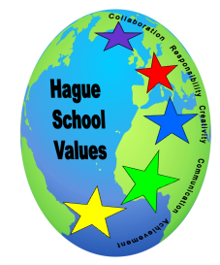
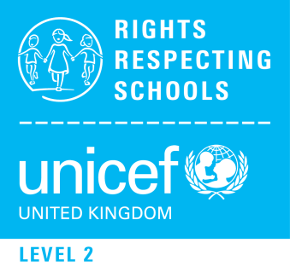
Promoting British Values and Our Five Star Values at Hague Primary School
Approved by: | Main Governors  Chair of Governors | Date: 6th March 2019  Mike Coleman
Last reviewed on: | November 2017
Next full review due: | January 2022

Hague is a values led and rights respecting school. Respecting children’s rights is at the heart of everything we do. We actively teach our children about the United Nations Conventions for the Rights of Children (UNCRC). This means that our children learn about children’s rights, their global issues with opportunities to develop attitudes and behaviours that reflect dignity for all, have shared social and moral purpose.

Our 5 Star Values were developed and introduced over time through the use of British Values, initially through whole school involvement from staff, then pupils and parents.

By learning about the work of UNICEF, the UNCRC Articles and Charters through assemblies, the curriculum working with partnership schools and having special events our children learn that they are given rights which should be respected by children and adults. They should be
- informed about their rights
- helped to exercise their rights
- able to enforce their rights
- supported by adults to advocate young people’s rights

These themes are integrated into the School Curriculum Map, Assemblies, RE and PSHE Jigsaw Lessons and partnership schools in Tower Hamlets and Spain. The school has for many years been values led. Respect and support each other to do the best we can is a school aim.

The DfE states that there is a need “to create and enforce a clear and rigorous expectation on all schools to promote the fundamental British values of democracy, the rule of law, individual liberty and mutual respect and tolerance of those with different faiths and beliefs.”

The promotion of British Values and Rights Respecting behaviour supports the school’s safeguarding Prevent Strategy. All adults and visitors to Hague are expected to follow the charters, respect and promote our school values. At Hague these values are reinforced regularly across the school in the following ways:

Democracy
Pupils are encouraged to discuss and debate topics of interest, express their views and make a meaningful contribution to school life. ‘Big Questions’ about the literacy theme or class topics are considered. Each year the children decide upon their Rights Respecting Class Charter which links to respect for school code of conduct or rules. All the children contribute to the drawing up of the class charters.

We have a school council which meets regularly with the Learning Mentor to discuss issues raised. The School Councillors are our Rights Respecting Ambassadors. They are elected class members. Awareness of Democracy is raised by linking knowledge of General Election to school elections. Pupils are encouraged to vote on a range of pupil led initiatives including fund raising ideas for School Gala or charities that interest pupils. The School participates in East 1 School’s Pupil Parliament Forum. The E1 Pupil Parliament decide through school consultations and working parties the action plans and celebrations for Human Rights and Environmental Issues which are relevant for our schools to campaign on i.e parking and pollution.

The Rule of Law
The importance of laws, be it those that govern the class, the school, or the country, are consistently reinforced at Hague through Hague’s Golden Charter or through discussion about inappropriate behaviour choices. This Charter has been consulted upon by pupils, staff, governors and parents. Pupils are taught from an early age the value and reasons behind rules and laws, that they govern and protect us, the responsibilities that this involves and the consequences when laws are broken. Visits from authorities such as the Police, Fire and Medical services help reinforce this message.

Individual Liberty
Pupils are encouraged to know, understand and exercise their rights and personal freedoms and advised how to exercise these safely, for example through our e-Safety and PSHE lessons. They also understand that we need to respect our own and others rights. Children respond to surveys and questionnaire where they are able to put forward their views about the school. Children have opportunities to choose when signing up for clubs, Golden Time, challenging themselves in their learning. They are encouraged to use their talents to volunteer for school roles as Digital Leaders, Young Sports Leaders or Healthy Lives Champions. Though focus events or lessons promoted by UNICEF Day for Change or Outright!

Mutual Respect
Mutual respect is at the heart of our values. Children learn that their behaviours have an effect on their own rights and those of others. All members of the school community are taught to treat each other with respect and dignity.

Tolerance of those of Different Faiths and Beliefs
At Hague we actively promote diversity through our celebrations of different faiths and cultures. Religious Education lessons and PSHE lessons reinforce messages of tolerance and respect for others. The children visit places of worship that are important to different faiths. As a school we work closely with families from different faiths in order to ensure that all children are included.

We offer a culturally rich and broad curriculum. All major religions are studied and respected and global dimension work is embedded where relevant. These curriculum topics offer children the chance to reflect on our core values and British values

Hague has five star values which have been discussed and agreed by Hague Staff and most importantly Hague Pupils. These are the values that we all think will support children to achieve their potential and maximise their future life chances.

- Responsibility
- Collaboration
- Creativity
- Communication
- Achievement

The children at Hague need to be seen and heard demonstrating the values in and around school, in the playground and in the dinner hall out and about for offsite learning.

We encourage everyone to look out for those who demonstrate the values so they can be nominated for a star award. Nominations for the Golden Book come from adults and pupils to acknowledge and praise children who work towards Star Values and Rights Respecting Behaviour.

We have a Star Values Award Ceremony at the end of each term to celebrate those who contribute to school life and the wider community, respect and support each other to do the best we can through learning about shared values.

Monitoring
Curriculum and British Values mapping exercises with staff ensure that the curriculum is values led. Curriculum Governors review Curriculum Maps. Prevent Curriculum Lead : Sam Fish

